**DR. AMBEDKAR COLLEGE, DEEKSHABHOOMI, NAGPUR**

**HR Lecture Series**

**Academic Session- 2024-25**

|  |  |
| --- | --- |
| **NAME OF THE PROGRAMME:** | HR Lecture on **‘NEP-2020: OPPORTUNITIES AND CHALLENGES’** |
| **NAME OF THE GUEST SPEAKER:** | **DR P.B. MAHESHWARY** |
| **NAME OF THE PROGRAMME**  **ORGANIZER:** | Dr Aarti Wazalwar |
| **DATE AND DAY:** | 7th April 2025, Monday |
| **TIME:** | 10.30 A.M |
| **TOTAL NUMBER OF PARTICIPANTS** | **71** |
| **VENUE:** | ROOM NO. 1, MAIN BUILDING  DR. AMBEDKAR COLLEGE, NAGPUR. |

**REPORT OF ‘NEP-2020: OPPORTUNITIES AND CHALLENGES’**

**BY**

**DR P.B. MAHESHWARY**

The HR Cell of Dr Ambedkar College, Deekshabhoomi, Nagpur organized a talk on **‘NEP-2020: OPPORTUNITIES AND CHALLENGES’** to address the growing concerns about implementation of NEP and the challenges faced by the staff members. The talk was organized on **7th April 2025, Monday** in Room no.1 at 10.30 am. The guest speaker invited was Dr P.B. Maheshwary, Dean, Science and Technology, RTMNU, Nagpur. The talk aimed to equip employees with practical tools and strategies to manage the newly introduced NEP-2020 effectively. It was organized with an objective of raising awareness about the Opportunities and Challenges faced by staff members while implementing NEP-2020.

The topics that were covered in the session were, credit system of NEP, enhancing skill based learning, importance of hands on practical experience in NEP and so on. Maheshwary Sir went at length to explain different prospects of Internships available for students and also threw light about OJT. The talk concluded with a Question hour session where a lot of participants asked questions to Sir.

The talk of **NEP-2020: OPPORTUNITIES AND CHALLENGES** in the HR Lecture Series has proven to be a valuable initiative, enhancing staff know how of the NEP-2020 while looking at NEP in a different light with a different perspective. Principal of the college Dr Deepa Panhekar and HR Cell Co-Coordinator Dr Aarti Wazalwar were prominently present for the program.

The event was a great success and proved to be extremely informative for all attendees. The session not only highlighted the transformative vision of NEP-2020 but also encouraged the academic community to engage proactively with its implementation.

The program was conducted by Dr Karuna Sahani. The talk was attended by around 71 staff members.

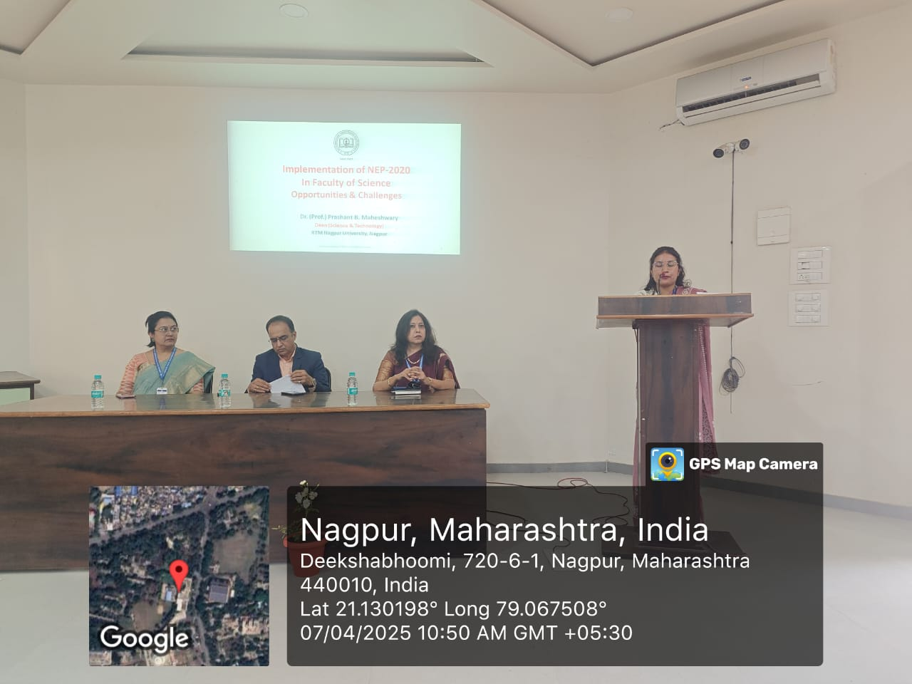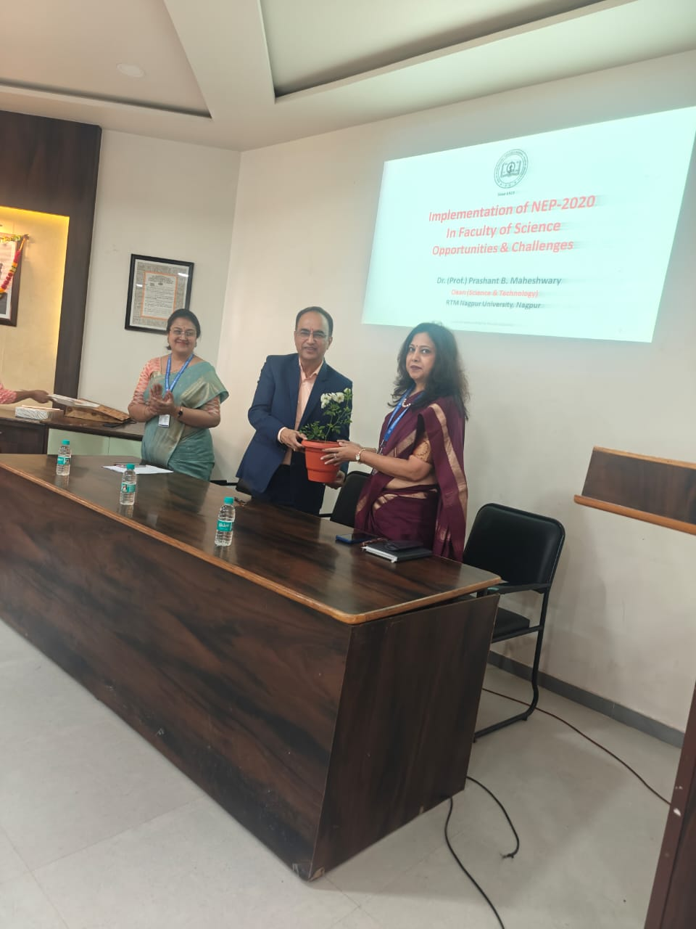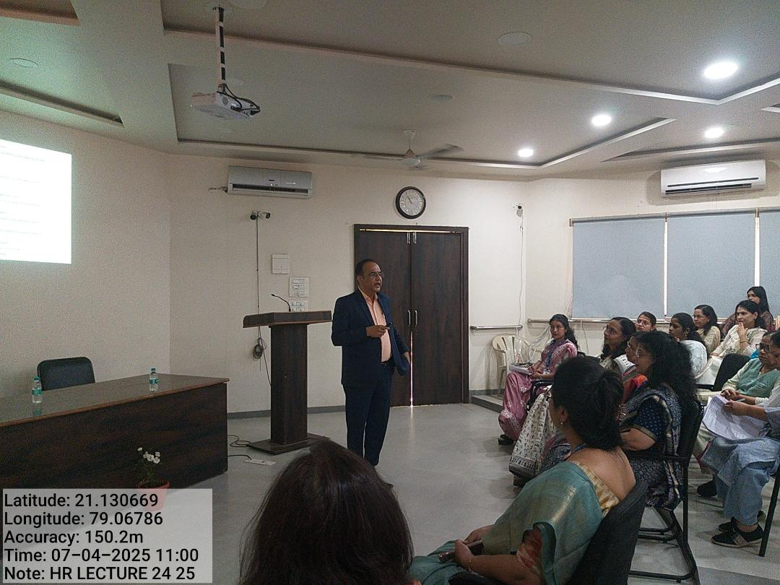

**Attendance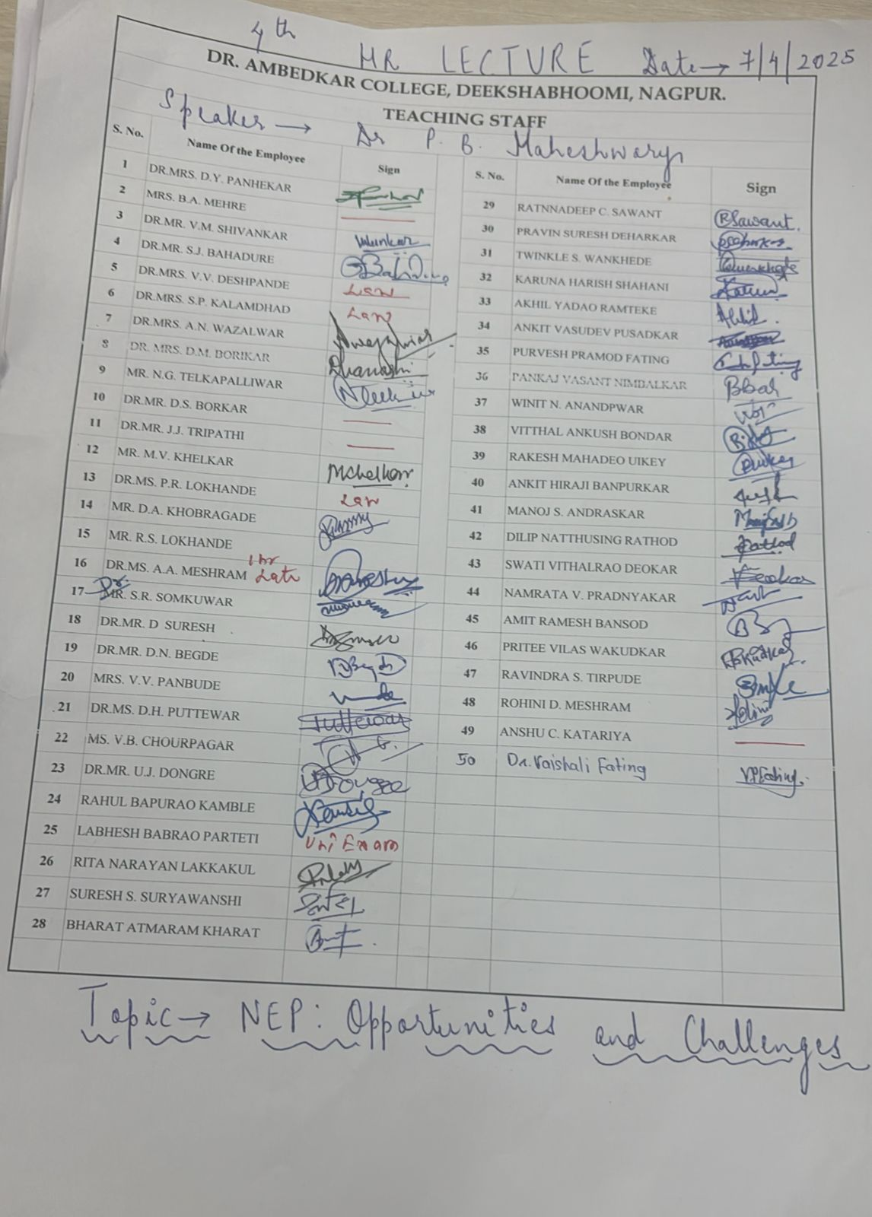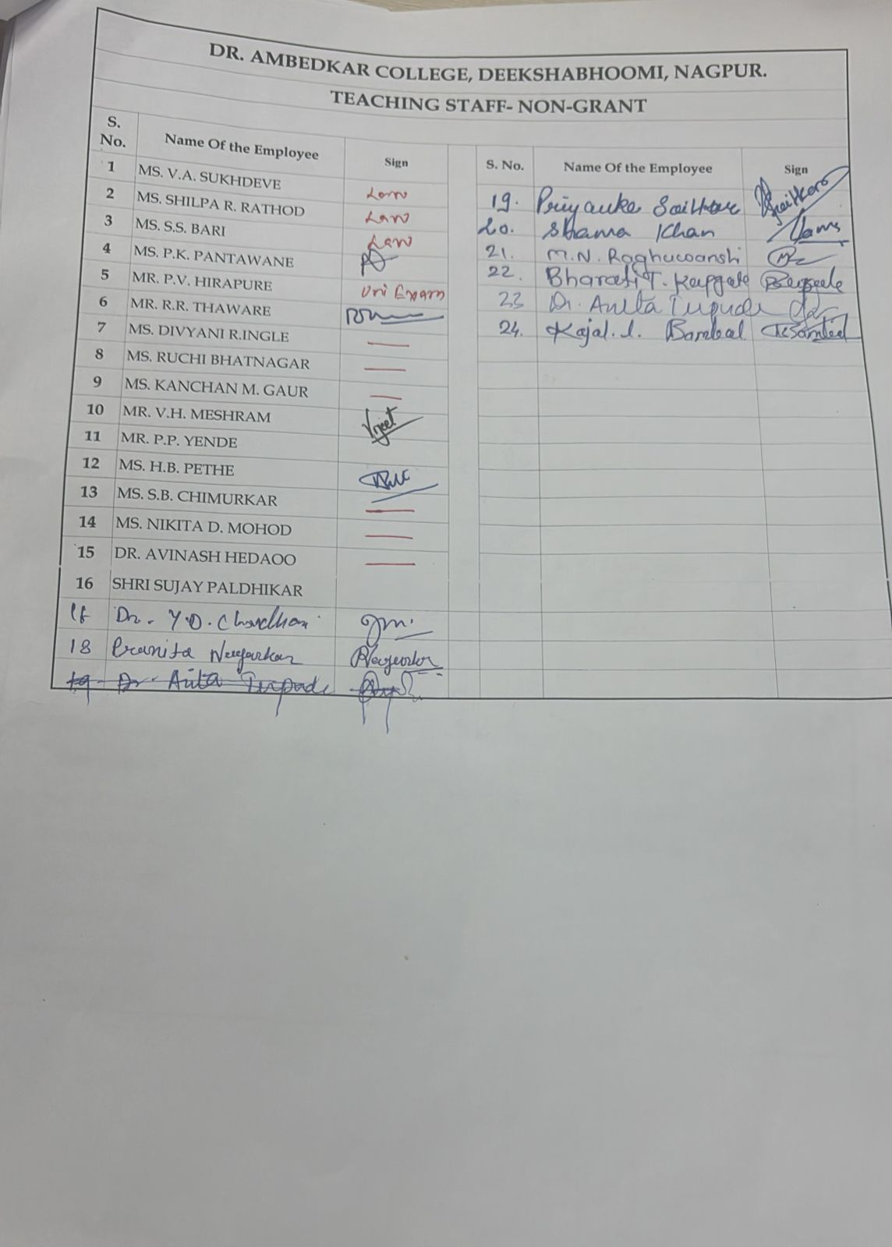K**

